**29.Body with package**

**CREATE TABLE:**

CREATE TABLE employees (

emp_id NUMBER PRIMARY KEY,

salary NUMBER

);

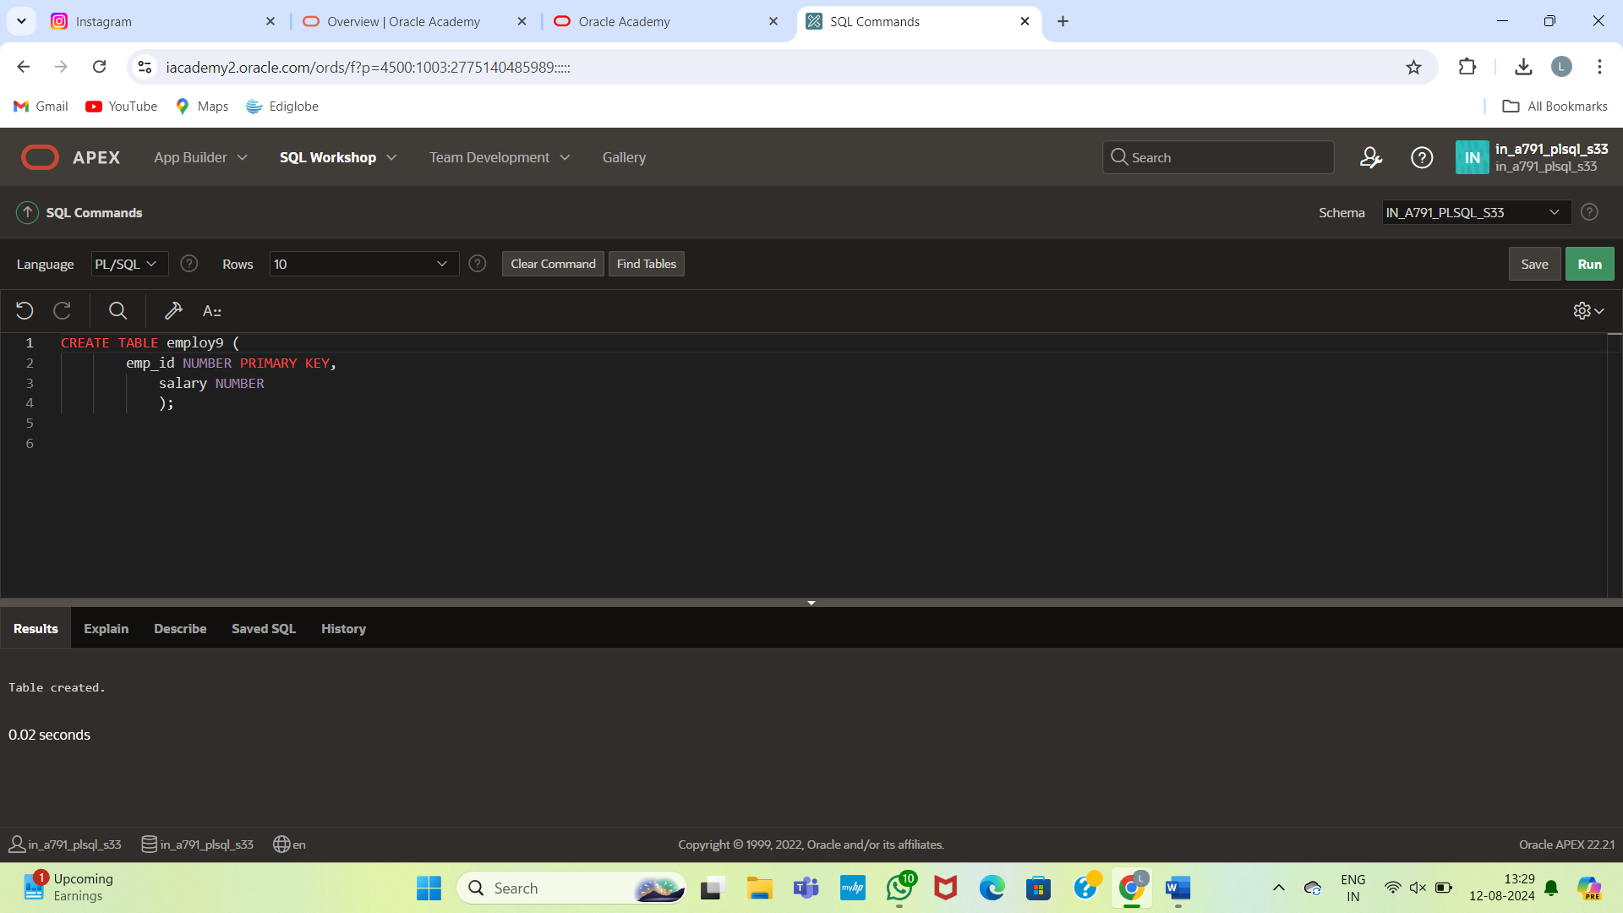

INSERT INTO employees (emp_id, salary)

VALUES (101, 30000);

INSERT INTO employees (emp_id, salary)

VALUES (102, 35000);

INSERT INTO employees (emp_id, salary)

VALUES (103, 28000);

INSERT INTO employees (emp_id, salary)

VALUES (100, 24000);

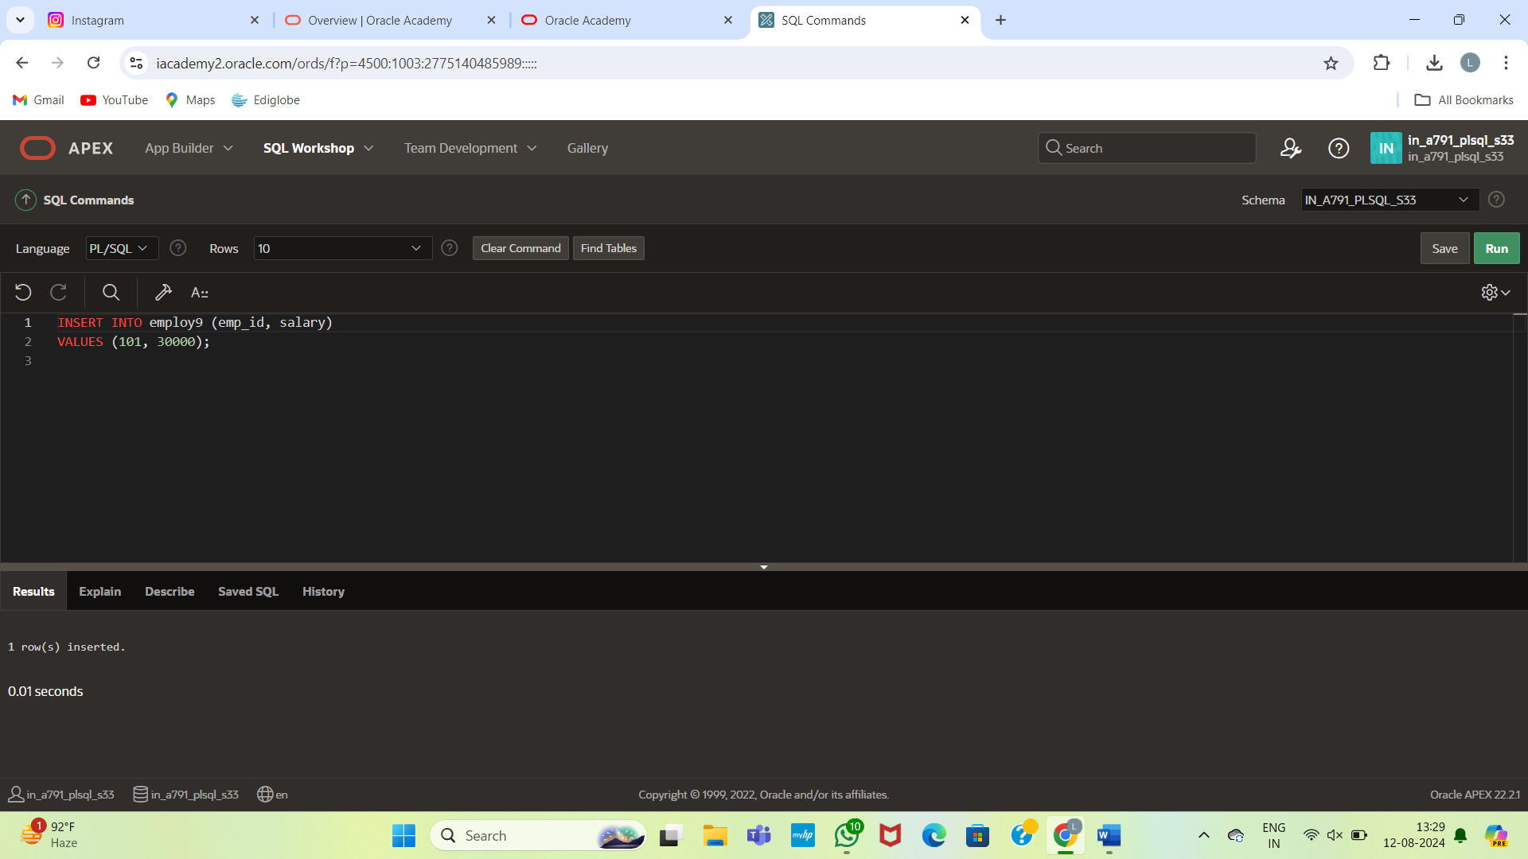

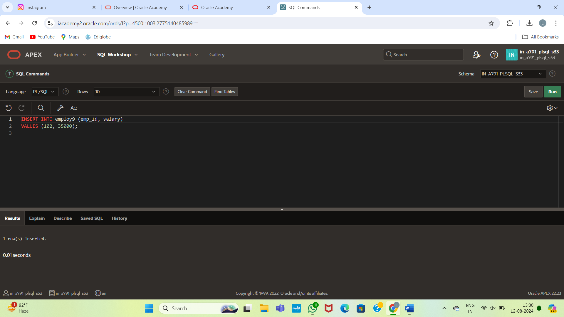

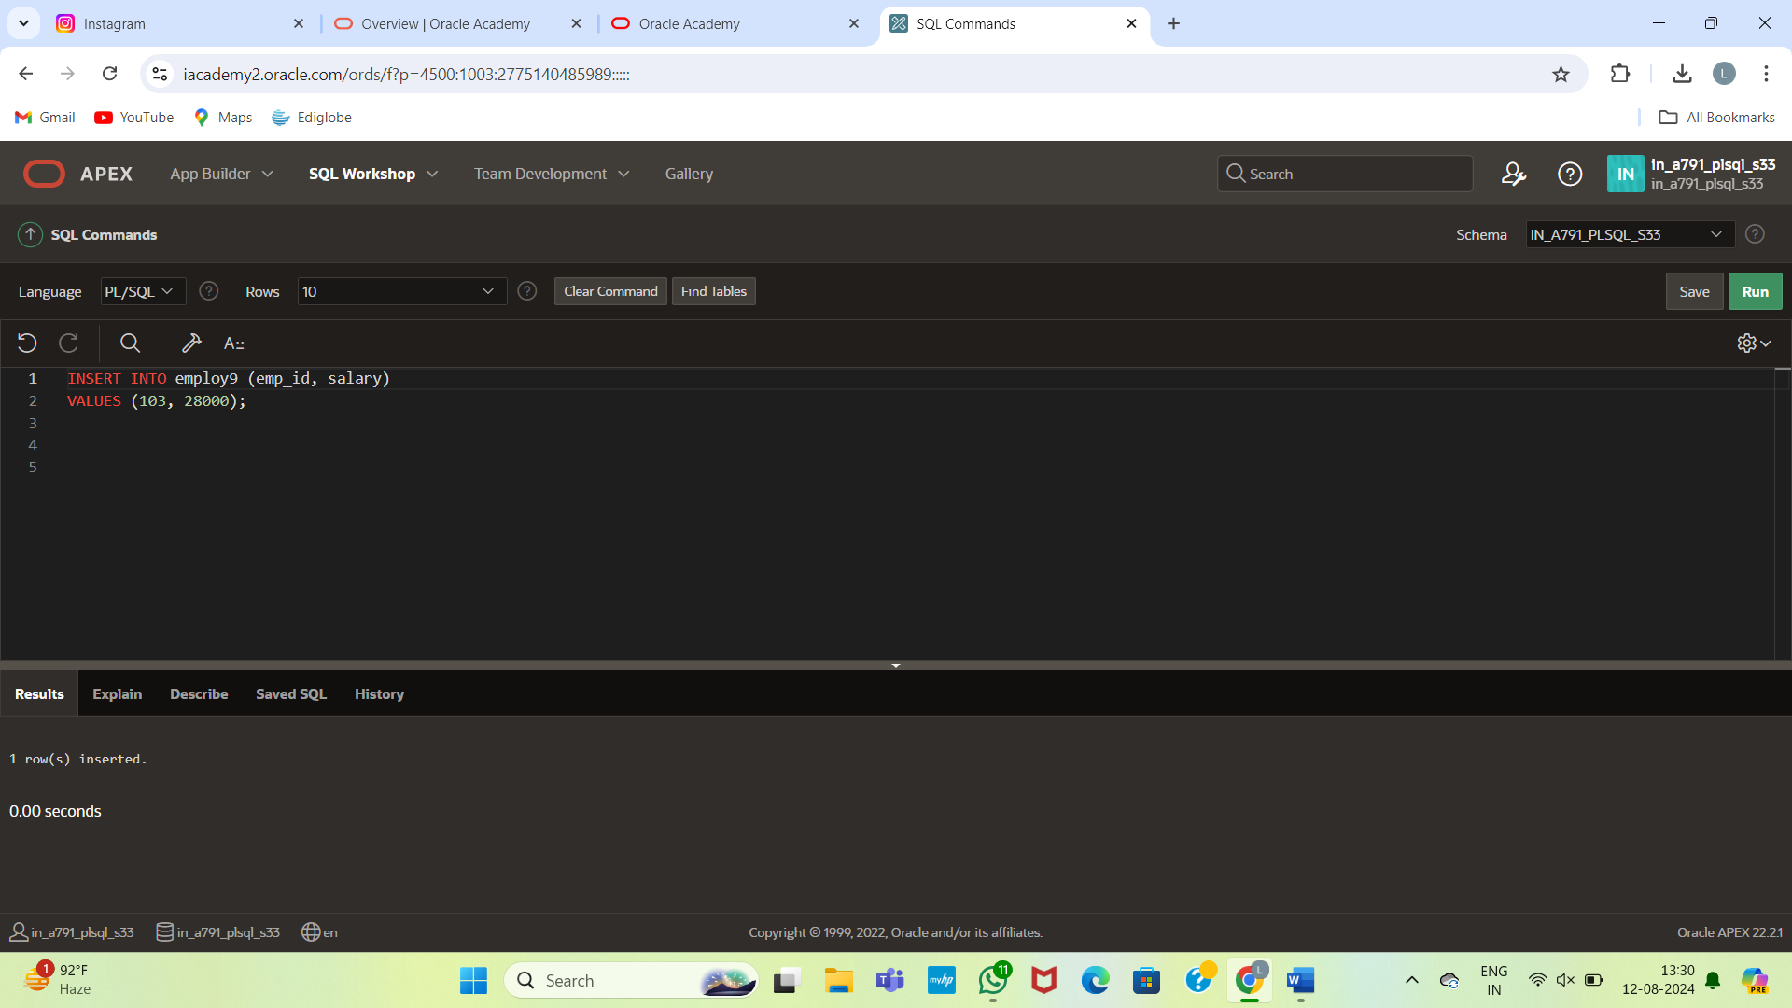

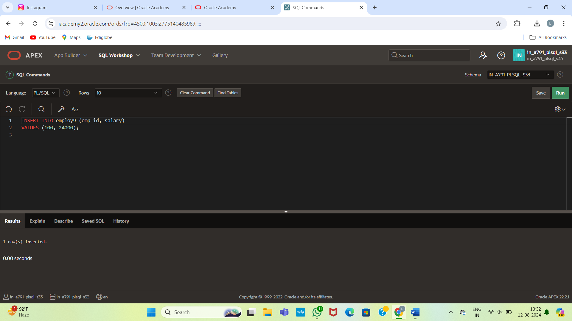

CREATE OR REPLACE PACKAGE salary_pkg IS

g_max_sal_raise NUMBER := 10000; -- Maximum allowed salary raise

v_old_salary NUMBER; -- To store the old salary for comparison

PROCEDURE update_sal(p_emp_id NUMBER, p_new_salary NUMBER);

FUNCTION validate_raise(p_old_salary NUMBER, p_new_salary NUMBER) RETURN BOOLEAN;

END salary_pkg;

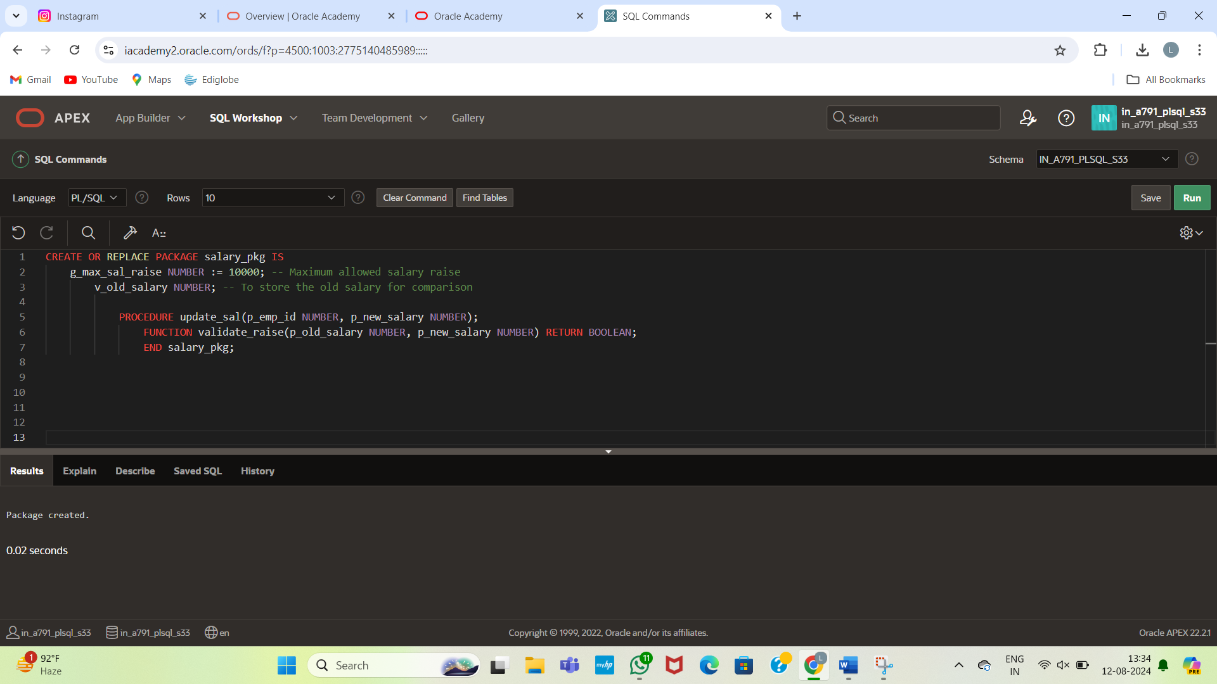

CREATE OR REPLACE PACKAGE BODY salary_pkg IS

-- Procedure to update the salary of an employee

PROCEDURE update_sal(p_emp_id NUMBER, p_new_salary NUMBER) IS

BEGIN

SELECT salary INTO v_old_salary FROM employees WHERE emp_id = p_emp_id;

UPDATE employees

SET salary = p_new_salary

WHERE emp_id = p_emp_id;

END update_sal;

-- Function to validate if the raise is within allowed limits

FUNCTION validate_raise(p_old_salary NUMBER, p_new_salary NUMBER) RETURN BOOLEAN IS

BEGIN

IF (p_new_salary - p_old_salary) <= g_max_sal_raise THEN

RETURN TRUE;

ELSE

RETURN FALSE;

END IF;

END validate_raise;

END salary_pkg;

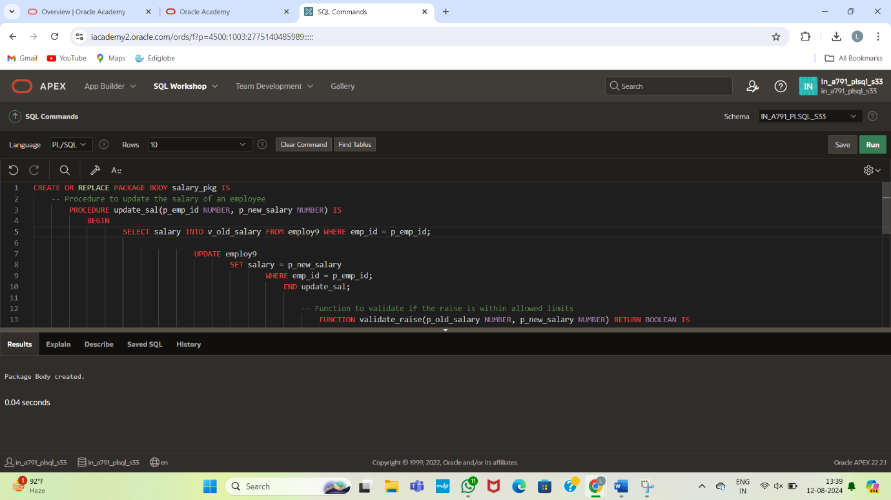

DECLARE

v_bool BOOLEAN;

v_number NUMBER;

BEGIN

salary_pkg.update_sal(100, 25000); -- Updates the salary of employee 100 to 25000

v_bool := salary_pkg.validate_raise(24000, 25000); -- Checks if the raise from 24000 to 25000 is valid

v_number := salary_pkg.g_max_sal_raise; -- Retrieves the maximum salary raise allowed

v_number := salary_pkg.v_old_salary; -- Retrieves the old salary before the update

END;

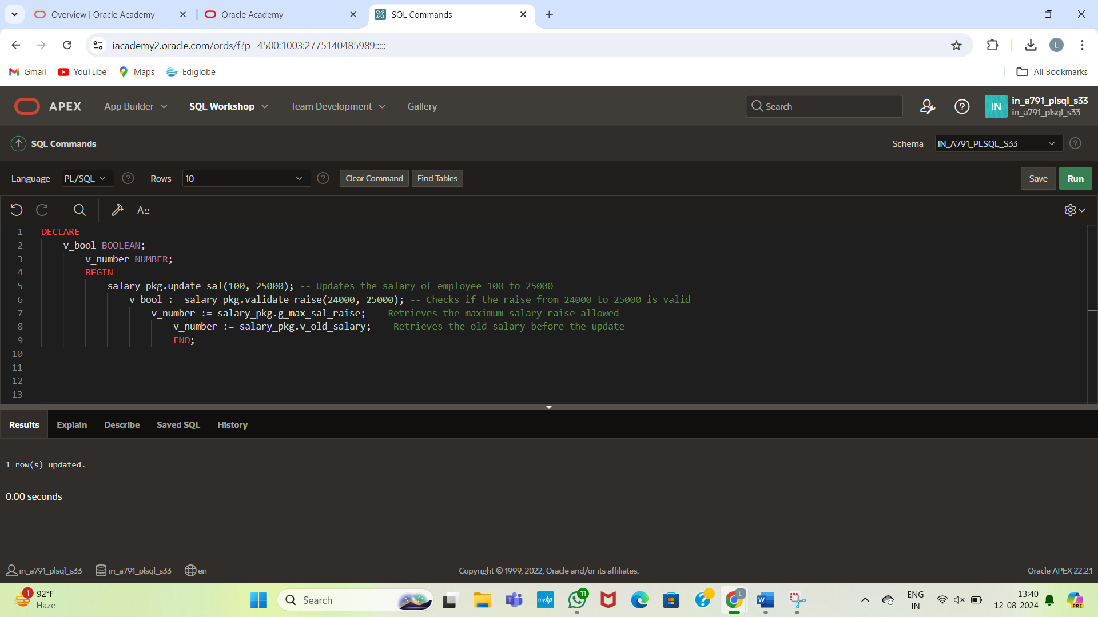

Select * from employee;

